**Mall Management System**

**Name:**

**Student ID:**

**Professor:**

**Introduction**

The Shopping Mall Management System will allow more than one shop owner to set up different shops, to sell various products under one roof i.e. mall. The mall performs the creation of a set of different shops, such as a book store, a shoe store, clothes store, jewellery store etc. In the existing mechanism customers need to search for the shops manually in a mall. Shop owners also directly contact to the mall administrator for their new shop setup. Even mall administrator is also maintaining the shops data manually. It is like storing information in records. It will create the burden for the management to maintain all the records. It is very much time consuming process.

The project is going to be developed is web based application which is shopping mall management system .This application can be applied on any shop .The Mall owners the super user and has complete control over all the activities that can be performed. The application notifies the administrator of all shop creation requests, and the administrator can then approve or reject them. The administrator maintain whole mall database. That means updation, deletion, reset tasks are maintained. When the request is approved by the mall administrator and from there on is given the role of shop owner. The shop owner is responsible for setting up the shop and maintaining it. A mall customer can browse mall details where ever they want and view the shops which place they can be placed or setup in a mall and also view discounts of that shops.

**Technologies used:**

**Development Environment (IDE):** NET BEANS

**Database platform:** MYSQL.

**Server-Side Technologies:** PHP

**Client-Side Technologies:** HTML5, CSS, Bootstrap.

**UML Diagrams:**

**UML DIAGRAMS:**

The Unified Modelling Language (UML) is used to specify, visualize, modify, construct and document the artefacts of an object-oriented software intensive system under development. UML describes the real time systems it is very important to make a conceptual model and then proceed gradually. Conceptual model of UML can be mastered by learning the following three major elements:

1. UML building blocks
2. Rules to connect the building blocks
3. Common mechanisms of UML

The building blocks of UML can be defined as:

* a) Things
* b) Relationships
* c) Diagrams

# (a) Things:

Things are the most important building blocks of UML. Things can be:

* 1.Structural
* 2.Behavioral
* 3.Grouping
* 4.Annotational

**1. Structural things**: The Structural things define the static part of the model. They represent physical and conceptual elements. Following are the brief descriptions of the structural things.

## A) Class:

Class represents set of objects having similar responsibilities.

class

## B) Interface:

Interface defines a set of operations which specify the responsibility of a class.

Interface

## C) Collaboration:

Collaboration defines interaction between elements.

Collaboration

## D) Use case:

Use case represents a set of actions performed by a system for a specific goal.

Use case

## E) Component:

Component describes physical part of a system.

Component

## F) Node:

A node can be defined as a physical element that exists at run time.

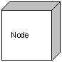

# 2. Behavioral things: A behavioral thing consists of the dynamic parts of UML models. Following are the behavioral things:

## A) Interaction:

Interaction is defined as a behavior that consists of a group of messages exchanged among elements to accomplish a specific task.

Interaction

## B) State machine:

State machine is useful when the state of an object in its life cycle is important. It defines the sequence of states an object goes through in response to events. Events are external factors responsible for state change.

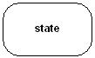

# 3. Grouping things: Grouping things can be defined as a mechanism to group elements of a UML model together. There is only one grouping thing available:

## Package:

Package is the only one grouping thing available for gathering structural and behavioral things.

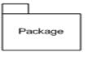

# 4. Annotational things: Annotational things can be defined as a mechanism to capture remarks, descriptions, and comments of UML model elements. Note is the only one Annotational thing available.

## Note:

A note is used to render comments, constraints etc of an UML element.

Note

# (2) Relationships:

Relationship is another most important building block of UML. It shows how elements are associated with each other and this association describes the functionality of an application.

There are four kinds of relationships available.

## Dependency:

Dependency is a relationship between two things in which change in one element also affects the other one.

Dependency

## Association:

Association is basically a set of links that connects elements of an UML model. It also describes how many objects are taking part in that relationship.

Association

## Generalization:

Generalization can be defined as a relationship which connects a specialized element with a generalized element. It describes inheritance relationship in the world of objects.Generalization

## Realization:

Realization can be defined as a relationship in which two elements are connected. One element describes some responsibility which is not implemented and the other one implements them. This relationship exists in case of interfaces.

Realization

**UML Diagrams**:

UML includes the following nine diagrams and the details are described in the following chapters.

1. **Class diagram:** It describes the structure of a system by showing the system's classes, their attributes, and the relationships among the classes.
2. **Object diagram:** It shows a complete or partial view of the structure of a modelled system at a specific time.
3. **Use case diagram:** It shows the functionality provided by a system in terms of actors, their goals represented as use cases, and any dependencies among those use cases.
4. **Sequence diagram:** It shows how objects communicate with each other in terms of a sequence of messages. Also indicates the lifespan of objects relative to those messages
5. **Collaboration diagram:** It is a specific type of interaction diagram, where the focus is on timing constraints.
6. **Activity diagram:** It represents the business and operational step-by-step workflows of components in a system. An activity diagram shows the overall flow of control.
7. **State chart diagram:** It is standardized notation to describe many systems, from computer programs to business processes.
8. **Deployment diagram**: It serves to model the hardware used in system implementations, and the execution environments and artefacts deployed on the hardware.
9. **Component diagram:** It depicts how a software system is split up into components and shows the dependencies among these components.

**Use case Diagram:**



**Sequence Diagram:**



**Collaboration Diagram:**



**Activity Diagram:**

**Admin**



**Shop Owner:**



**User:**



**Class Diagram:**



**TECHNOLOGY DESCRIPTION**

**Software Description:**

* **HTML:**

Hyper Text Markup Language (HTML) is a language used to create hypertext documents that have hyper links embedded in them. It consists of tags embedded in the text of a document with HTML. We can build web pages or web documents. It is basically a formatting language and not a programming language. The browser reading the document interprets mark up tags to help format the document for subsequent display to a reader. HTML is a language for describing structured documents. HTML is a platform independent. WWW (World Wide Web) pages are written using HTML. HTML tags control in part the representation of the WWW page when view with web browser. The browser interprets HTML tags in the web document and displays it. Different browsers show data differently. Examples of browsers used to be web pages include:

1. Netscape
2. Internet Explorer

* **PHP:**

PHP is a server side scripting language and a powerful tool for making dynamic and interactive web pages.PHP Scripts are executed on server.PHP is an interpreted language. There is no need for compilation.PHP is faster than other scripting language Ex: ASP, JSP.

PHP – Personal Home Page. (Also called as Hypertext Pre-processor).

PHP is a widely used open source scripting language.PHP files can contain HTML, CSS, JavaScript and PHP Code.PHP codes are executed on the server and the result is returned to the browser as plain HTML.PHP files have extension “.php”.

**What Can PHP Do?**

* PHP can generate dynamic page content
* PHP can create, open, read, write, delete, and close files on the server
* PHP can collect form data
* PHP can send and receive cookies
* PHP can add, delete, modify data in your database
* PHP can be used to control user-access
* PHP can encrypt data

**Why PHP?**

* PHP runs on various platforms (Windows, Linux, UNIX, Mac OS X, etc.)
* PHP is compatible with almost all servers used today (Apache, IIS, etc.)
* PHP supports a wide range of databases

**How to Install PHP?**

To install PHP, first we have to install AMP (Apache, MySQL, and PHP) software stack.

There are many AMP options available according to your operating system.

* **WAMP** for Windows
* **LAMP** for Linux
* **MAMP** for Mac
* **SAMP** for Solaries
* **XAMPP** for all platforms

If your server has activated support for PHP you do not need to do anything.

Just create some .php files, place them in your web directory, and server will automatically parse them for you.

**Set Up PHP on Your Own PC**

However, if your server does not support PHP, you must:

* install a web server
* install PHP
* install a database, such as MySQL

**PHP 5 Syntax:-**

A PHP script can be placed anywhere in the document.

A PHP Script starts with **<?php** and ends with the **?>**.

<? Php

Content goes here

?>

The Default file extension for PHP files is “.php”.

A PHP file normally contains HTML tags and some PHP scripting code.

**XAMPP Control Panel:**

XAMPP stands for Cross-Platform (X), Apache (A), MySQL (M), PHP (P) and Perl (P). It is a simple, lightweight Apache distribution that makes it extremely easy for developers to create a local web server for testing purposes. Everything you need to set up a web server – server application (Apache), database (MySQL), and scripting language (PHP) – is included in a simple extractable file. XAMPP is also cross-platform, which means it works equally well on Linux, Mac and Windows. Since most actual web server deployments use the same components as XAMPP, it makes transitioning from a local test server to a live server is extremely easy as well

XAMPP has four primary components. These are:

**1. Apache:** Apache is the actual web server application that processes and delivers web content to a computer. Apache is the most popular web server online, powering nearly 54% of all websites.

**2. MySQL:** Every web application, howsoever simple or complicated, requires a database for storing collected data. MySQL, which is open source, is the world’s most popular database management system. It powers everything from hobbyist websites to professional platforms like WordPress.

**3. PHP:** PHP stands for Hypertext Pre-processor. It is a server-side scripting language that powers some of the most popular websites in the world, including WordPress and Facebook. It is open source, relatively easy to learn, and works perfectly with MySQL, making it a popular choice for web developers.

**4. Perl**: Perl is a high-level, dynamic programming language used extensively in network programming, system admin, etc. Although less popular for web development purposes, Perl has a lot of niche applications.

**Website Screenshots:**

Home page:

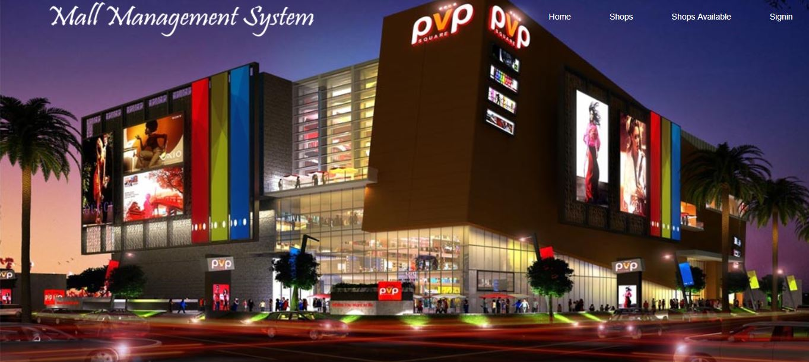

Login Page:

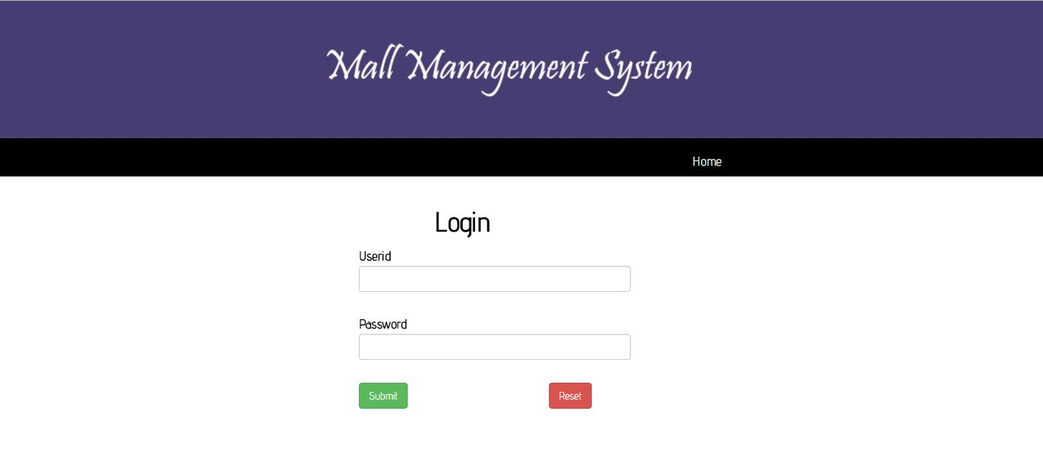

Admin Home

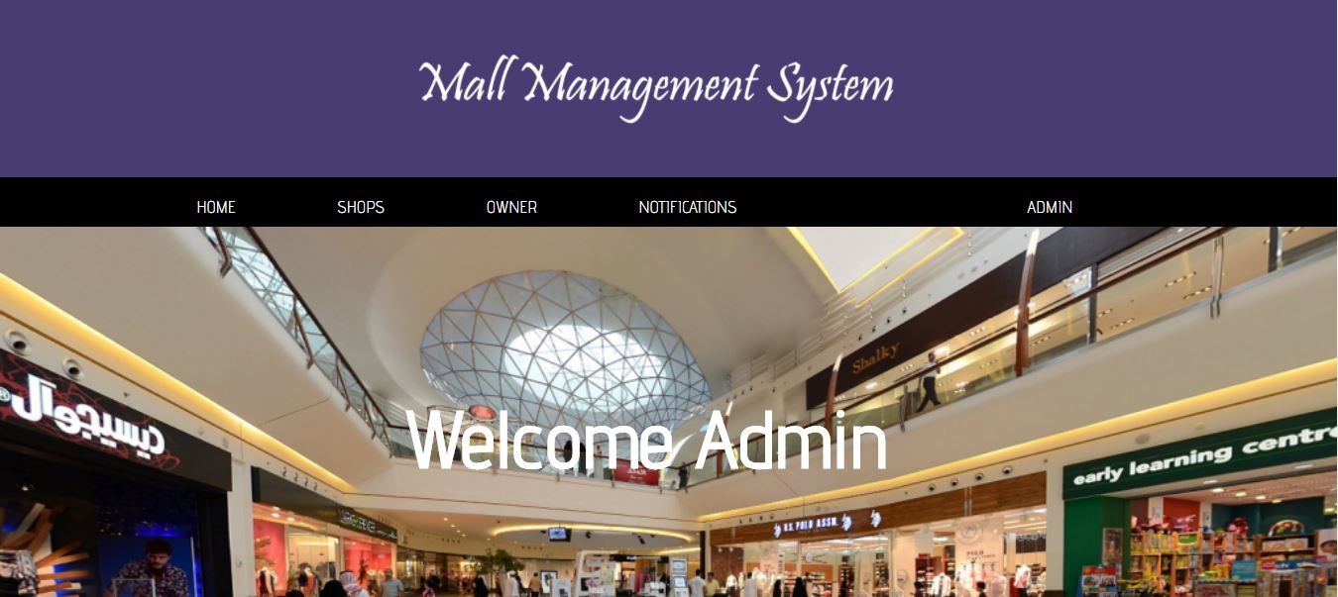

Add Shops:

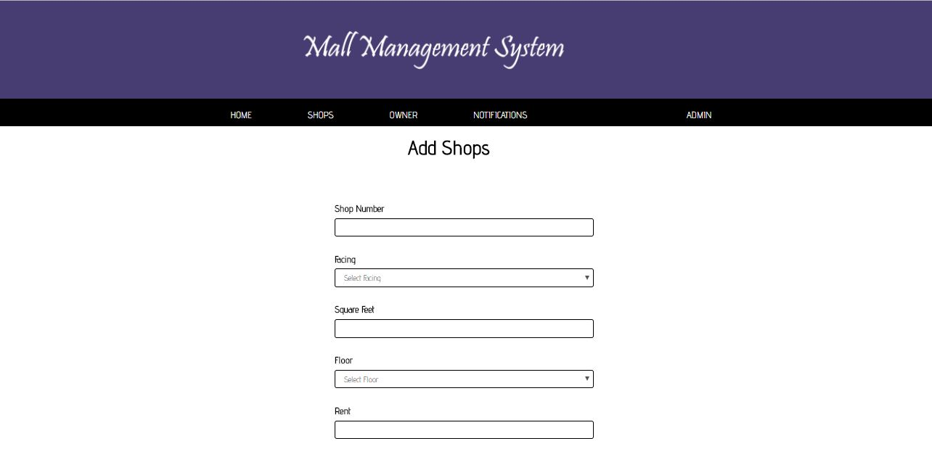

View Shops

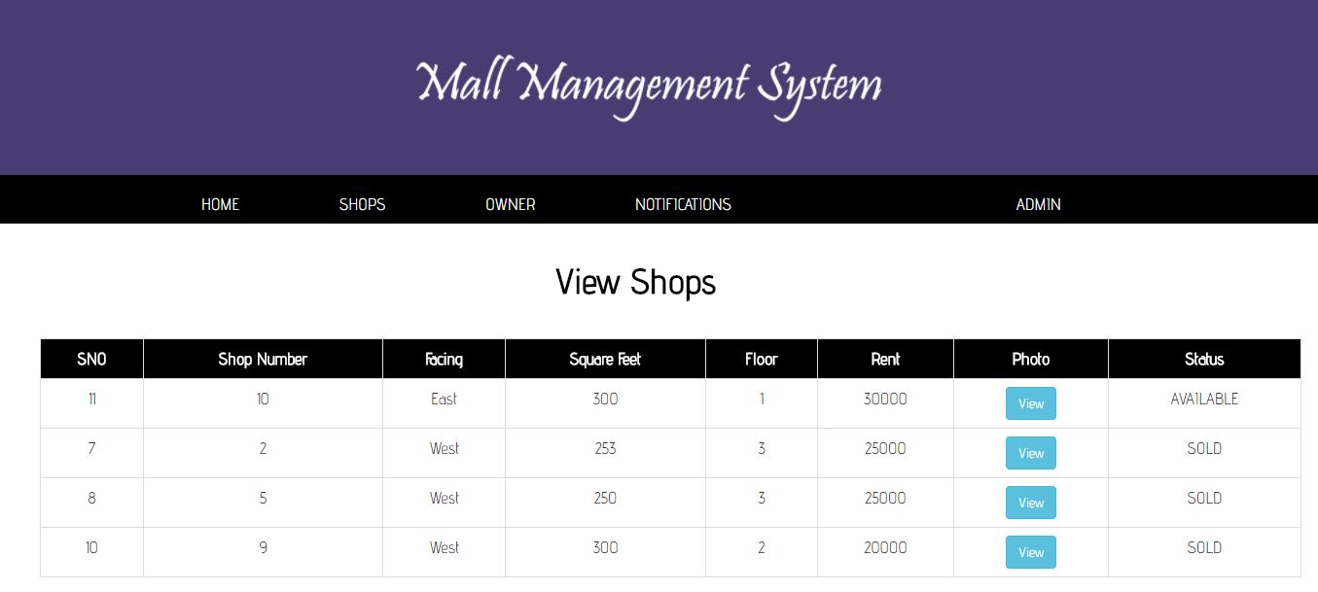

Edit Shops

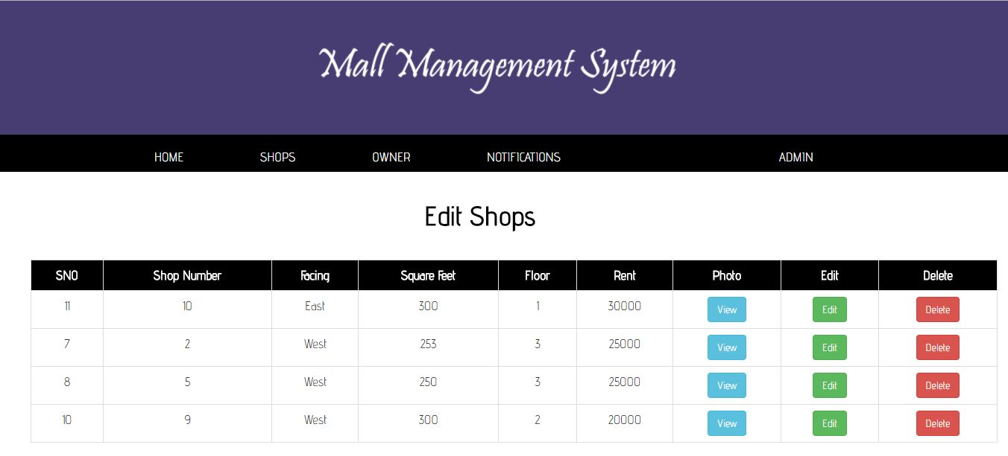

Add Owner:

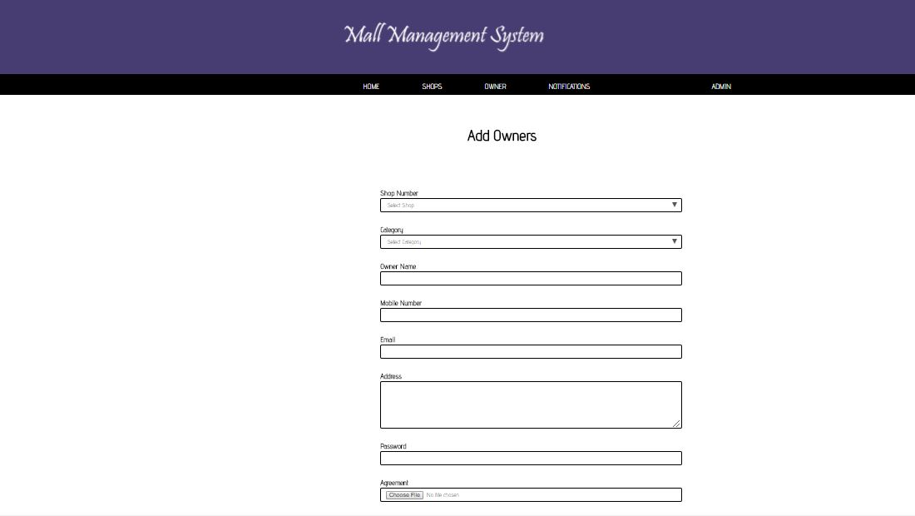

View Owners :

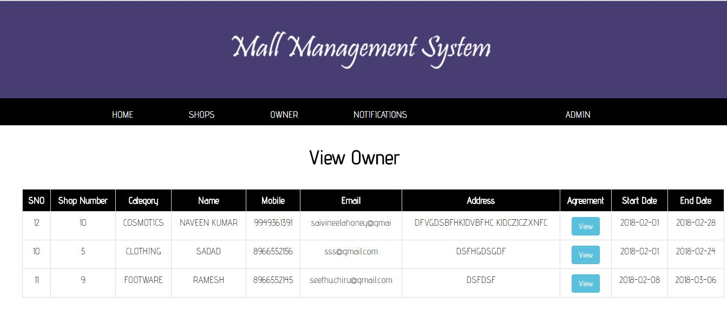

Publish Notifications:

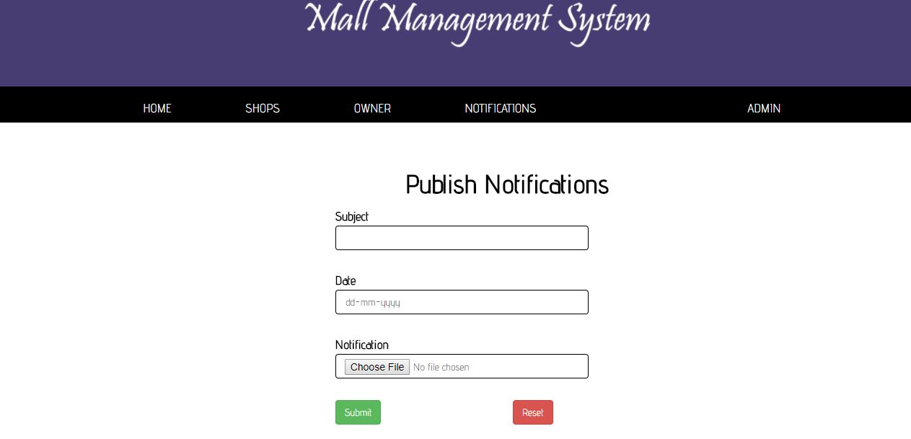

Change Password

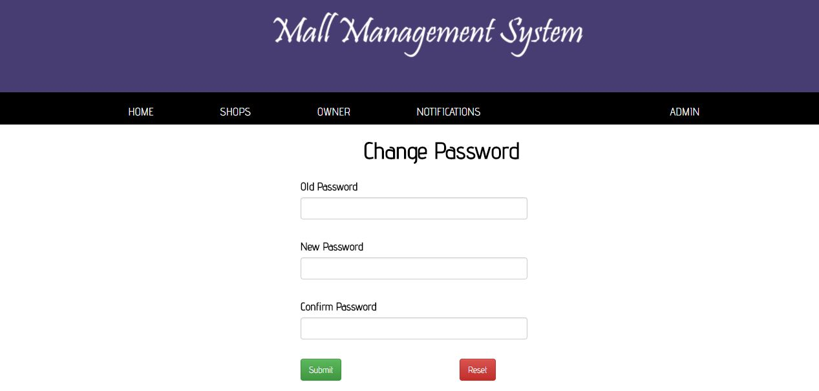

Owner Add Offer:

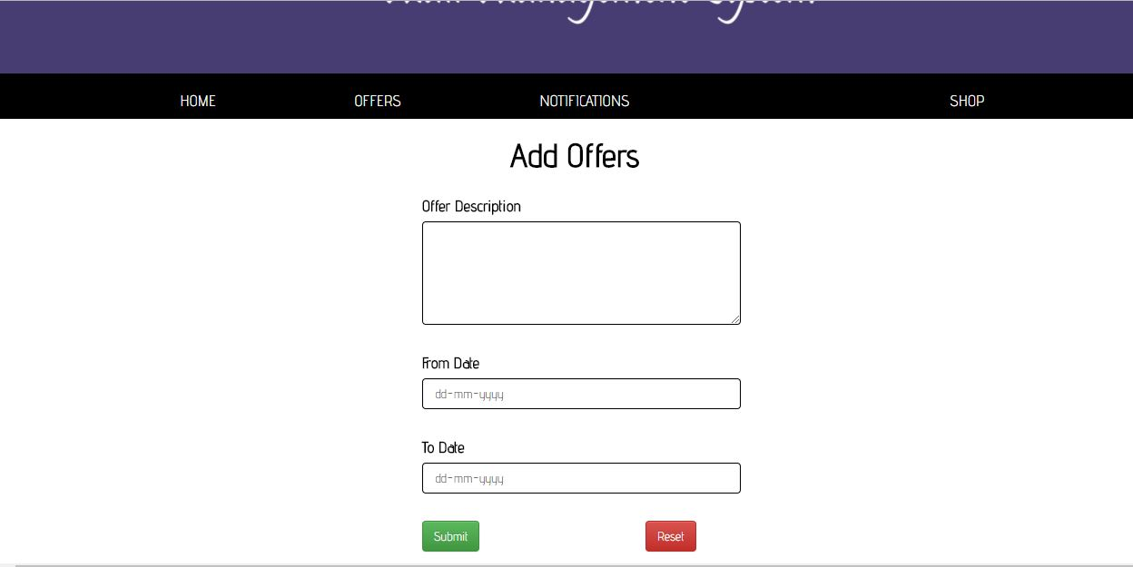

Publsih Notifications:

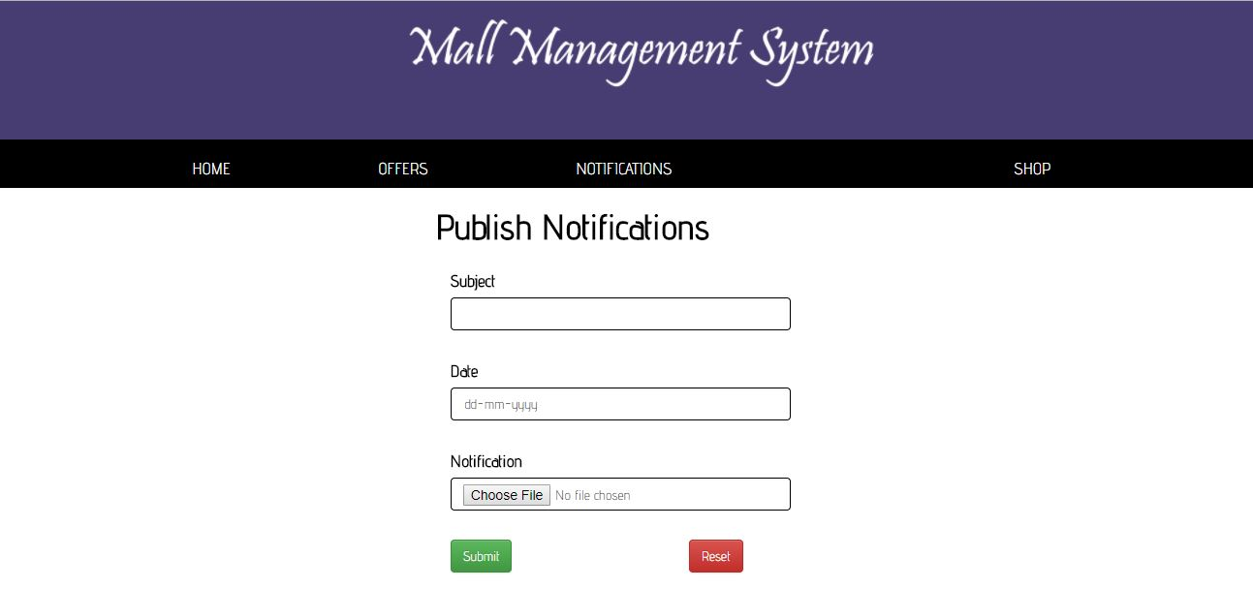

View Notifications

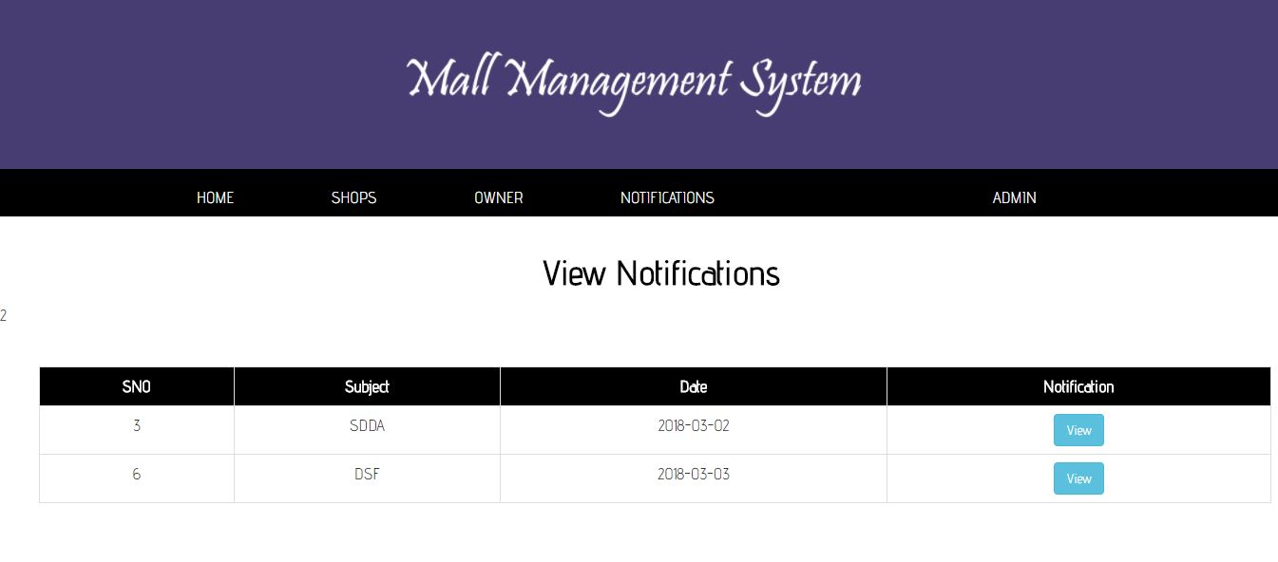

Offers

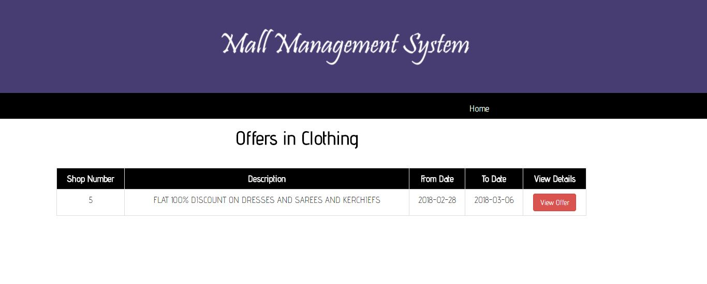

View Available Shops:

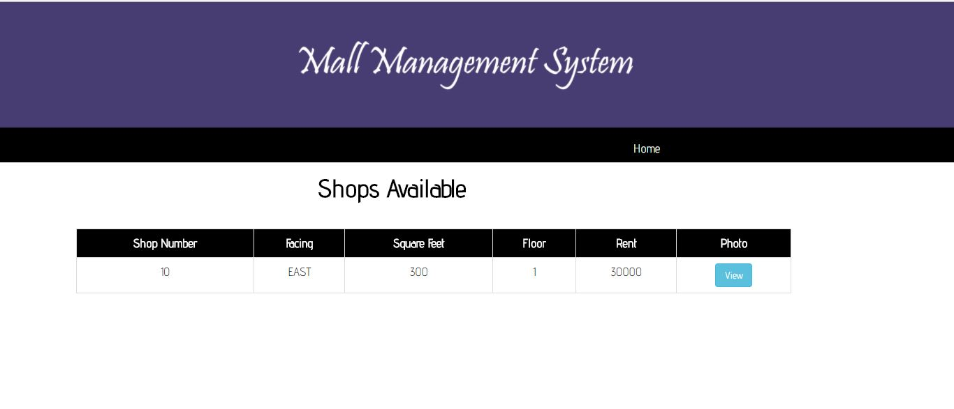

**MYSQL Screen Shots:**

The SQL Server consisting of following table:

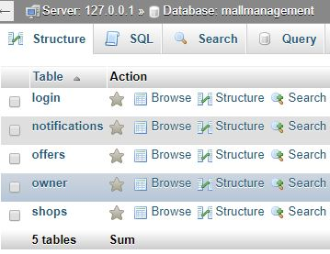

**Login Table:**

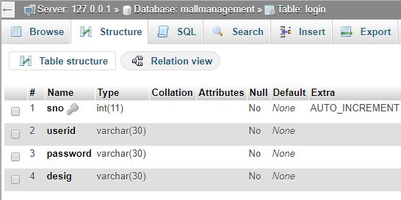

**Notifications Table:**

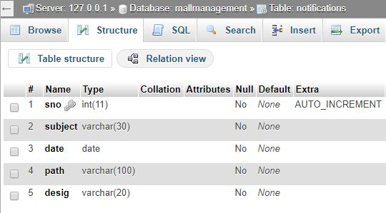

**Offers Table:**

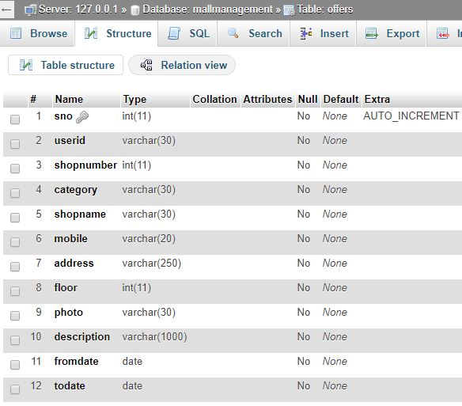

**Owners Table:**

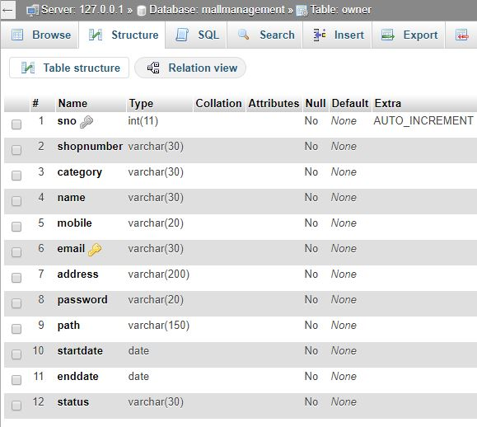

**Shops Table**

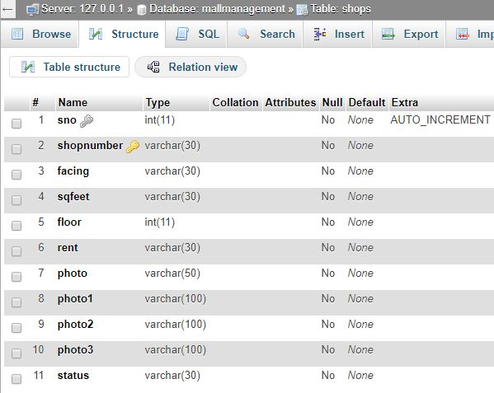

Reference:

1) http://www.w3schools.com/html/default.asp

2) http://www.w3schools.com/css/default.asp

3) <http://www.w3schools.com/bootstrap/default.asp>

4) <http://www.w3schools.com/sql/default.asp>

5) http://www.w3schools.com/php/default.asp